Lightweight Network Intrusion Detection System (IDS)
1. Main Objective
- Detect malicious traffic
- Classify attack types
2. Dataset Preparation
- CIC-IDS2017 study (Dataset created in a controlled environment).
- Understand features within dataset.
- Cleaning dataset (Missing values, duplicates, outliers, feature selection)
3. Target Variables
Binary
- BENIGN
- ATTACK
Multi-class (Need to understand concept of each attack to detect the patterns), not implementing all of them.
- BENIGN
- DoS
- DDoS
- Botnet
- PortScan
- Brute Force
- Web Attack
- Infiltration
- Heartbleed
4. Attack Labels in Dataset
Define target labels for different attacks.
5. Model Training
Find best model for training.
6. Evaluation
- Accuracy
- Precision
- Recall
- Confusion matrix
- Model comparison
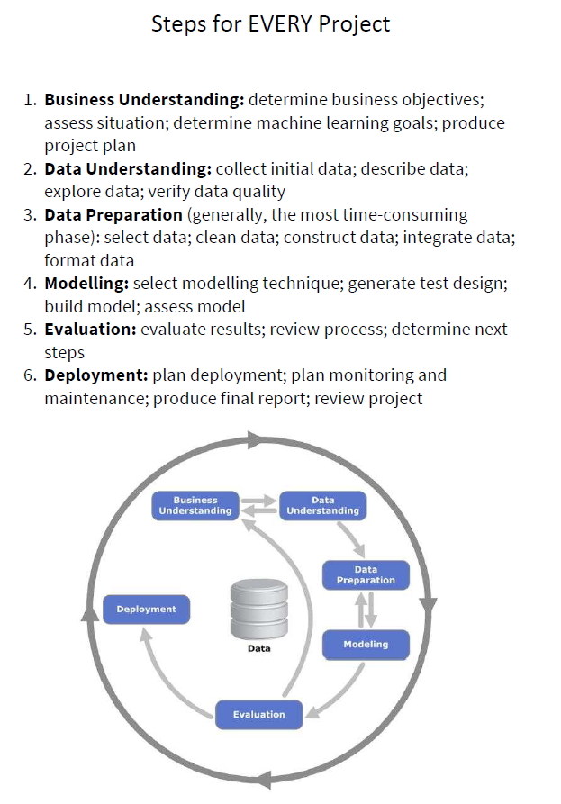
8. Deployment
- Pickle
- Saved model
- Dashboard with alerts.
9. Practical Testing (If possible, depends on time)
Create my own dataset using Kali Linux to simulate some attacks and try to use same model or different.

